Human Rights: A global achievement

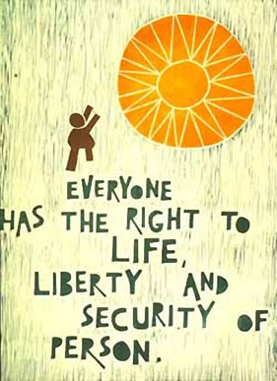
Human rights are the foundation of freedom, justice and peace.
Contempt for human rights have resulted in barbarous acts.
Human rights is a duty of everyone: government, individual or social agency.
Everyone is born free and equal in rights.
We need to radically opt for a society based on community and solidarity and equality through redistribution. Even if we have to leave our comfort zone.
Respect for the dignity of every human being and respect for the planet constitute the guiding principles. It means "more humanity, more social life, more care for our earth."

Some of these rights are:
You have the right to life, liberty and security.
You can choose your own religion or belief and live accordingly.
You are entitled to sufficient income so that your health is not compromised. You have the right to education.

Solidarity is not merely an individual matter, but has to do with how we organize our live together economic, ecological, social, cultural and
inter-religious. Solidarity is a form of resistance to despondency.
From that global solidarity we can work towards a world with a future for all, including the future generations.

Around the world, groups of people make these bold choices. They can inspire us. Solidarity across borders of space and time, to do in our own life, to give shape in our society and on a global scale, together with others.

Prayer
God, we seek you and may you find in every fellow man.
Because we are made in your image and likeness.
We hope and pray that we interact,
in a way we do not humiliate ourselves
and not violate the picture that we are of you.
Father of all men, no matter how limited and mortal we are,
we pray that we reveal you permanently
and that we will be your future for all people, beyond death.
We ask you this for today and every day.
Amen.

Intercessions
Lord and Saviour of the world, we pray
for those who, anywhere in the world, are committed to justice,
who stand up for the disadvantaged, who are striving sincerely for peace,
but find only discord and unwillingness on their way.
We pray that the soft values ​​may win.
Lord and Saviour of the world, we pray
for those, who are looking out for reconciliation,
but encountering obstinacy.
For those who are straightforward,
but bump into obduracy.
We pray that the soft forces may win.
Lord and Saviour of the world, we pray
for those who defend human rights, but are not heard.
For those who try to keep their spirits up,
but are attacked by the doom of others.
We pray that the soft forces may win.
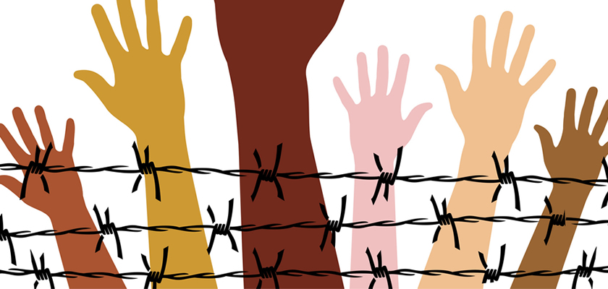

The Parable of the Good Samaritan
25 On one occasion an expert in the law stood up to test Jesus. “Teacher,” he asked, “what must I do to inherit eternal life?”
26 “What is written in the Law?” he replied. “How do you read it?”
27 He answered, “‘Love the Lord your God with all your heart and with all your soul and with all your strength and with all your mind’[c]; and, ‘Love your neighbor as yourself.’[d]”
28 “You have answered correctly,” Jesus replied. “Do this and you will live.”
29 But he wanted to justify himself, so he asked Jesus, “And who is my neighbor?”
30 In reply Jesus said: “A man was going down from Jerusalem to Jericho, when he was attacked by robbers. They stripped him of his clothes, beat him and went away, leaving him half dead. 31 A priest happened to be going down the same road, and when he saw the man, he passed by on the other side. 32 So too, a Levite, when he came to the place and saw him, passed by on the other side. 33 But a Samaritan, as he traveled, came where the man was; and when he saw him, he took pity on him. 34 He went to him and bandaged his wounds, pouring on oil and wine. Then he put the man on his own donkey, brought him to an inn and took care of him. 35 The next day he took out two denarii[e] and gave them to the innkeeper. ‘Look after him,’ he said, ‘and when I return, I will reimburse you for any extra expense you may have.’
36 “Which of these three do you think was a neighbor to the man who fell into the hands of robbers?”
37 The expert in the law replied, “The one who had mercy on him.”
Jesus told him, “Go and do likewise.”

Silence

Reflection
When God comes your way, it will be like a child, as a human being ...
Be alert so that you recognize him?
He will carry no halo, no title
or He will not have any respect.
He will be male or female, rich or poor - but that's not important.
He will be a man who is hungry. Feed him with your love.
He will be naked. Dressed him with your appreciation.
Is He in prison? Deliver Him through your understanding.
Perhaps he will be sick. Heal him with your warm confidence.
He will have thirst. Give him to drink from your righteousness.
If He feels strangely-lost, give him the home of your heart.
Be alert when God comes incognito on your way ...
Prayer
God of all people in our diversity we can enrich each other,
but we succumb to all our disputes.
Take away from our midst arrogance and intolerance,
pedantry and implacability.
Demolish everything that prevents us from to be
your children, and allies of one another.
Convert our hearts so that we our diversity of gifts, in unison,
and in the spirit of Jesus Christ, stand at the service of each other.
Thus is born your Empire:
a warm human world across all borders.
Amen.

